Being capable of big things
Creating opportunities to discover new paths is a key way mentors support students and defines how Jamie Trevitt, assistant professor of health administration and policy, has supported Jessica Linus ‘19, health administration and policy.
“I would not be here if it wasn’t for Jamie Trevitt,” shares Linus. “At first I wanted to be pre-med and pursue a career in obstetrics and gynecology to help with African women’s health,” remembers Linus. But that changed during a trip to Nigeria, where she shadowed doctors in a hospital. There she saw structural, staffing, and management needs that kept the hospital from being a greater benefit to the community.
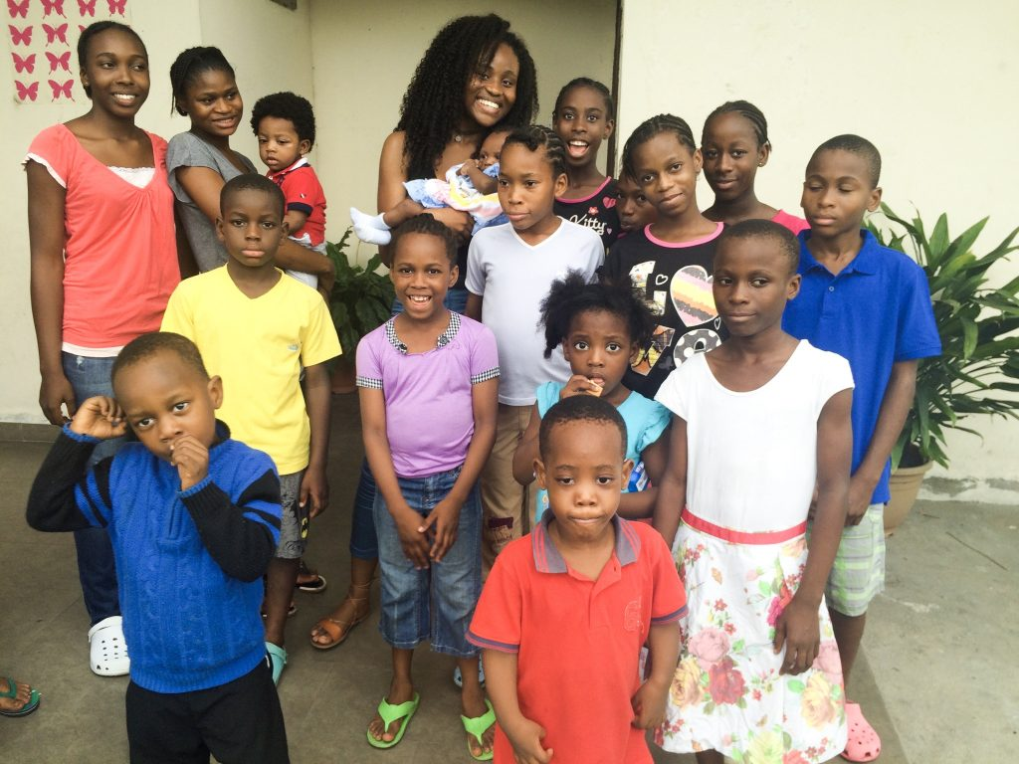
Jessica Linus at an orphanage during a service trip to Port Harcourt, Nigeria. Photo courtesy of Linus.

Following that experience, Trevitt helped Linus secure an internship in reproductive health in Rwanda through a National Science Foundation program. “The best part of my job as a professor and educator is helping students find their passion within the public health field,” says Trevitt.
The internship gave Linus first-hand experience conducting interviews, doing qualitative research, using data analysis software, working with Rwandan professors, and shadowing doctors in a hospital. She was amazed to find a thriving health system only twenty-five years after the Rwandan genocide. But she was also perplexed by the contrast she saw to Nigeria’s many economic and health care struggles.
“I had big questions,” explains Linus. “I needed to understand what made this Rwandan hospital thrive and find ways I could help the hospital in Nigeria do the same.”
Trevitt sees in Linus an emerging leader in international public health, and she knows that asking big questions and taking advantage of opportunities like the Fulbright will help her get there. “As a professor,” Trevitt explains, “there is no better reward than helping a student realize they are capable of big things and then watching them grow into a confident and knowledgeable expert that’s ready to make a difference in our global society.”

A new framework for understanding gender
When Sarah Chard met Robert Barrett ‘15—majoring in cultural anthropology as well as biochemistry and molecular biology—she was struck by the clarity of his interests. “Robert knew very early on that he wanted to find a research experience in biomedicine and anthropology, and study abroad in India,” remembers Chard, associate professor of sociology, anthropology, and health administration and policy. “The challenge was to determine how the pieces could fit together over several years.”
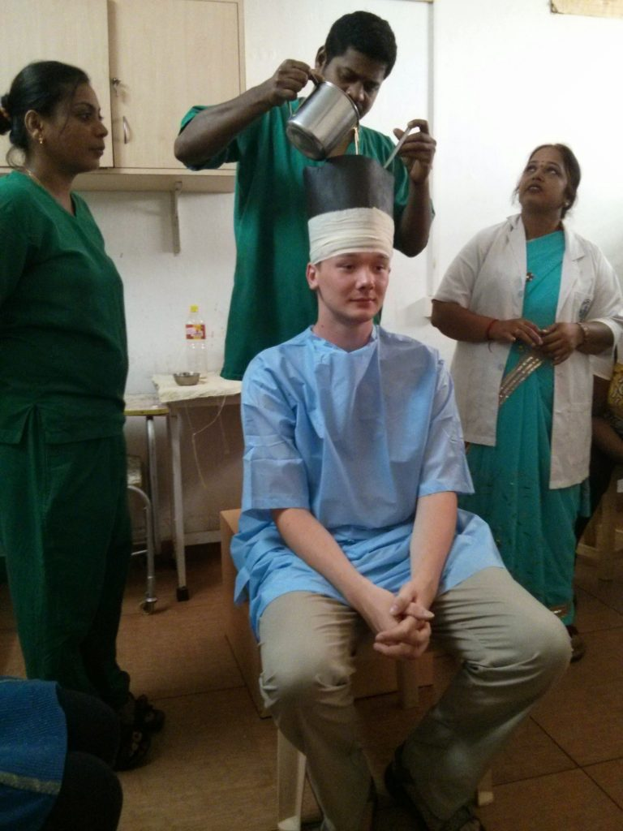
Robert Barrett receives a shiro vasti treatment during an Ayurvedic medicine class in India. Photo courtesy of Barrett.

Together Chard and Barrett explored what his unique path could look like. “There are many pathways. Validating them affirms the importance of ideas and recognizes students as scholars who bring new and exciting work to the discipline,” says Chard. “It’s important during conversations with students to help them foresee roadblocks and alternatives, and develop a flexible mindset.”
These conversations prepared Barrett to make the most of his study abroad experience in South India at Manipal University. “My research in India required me to learn a completely new framework for understanding gender, sexuality, and associated stigma,” he explains. “It tested my ability to use research methods across a language barrier, and provided concrete examples of the social determinants of health.”
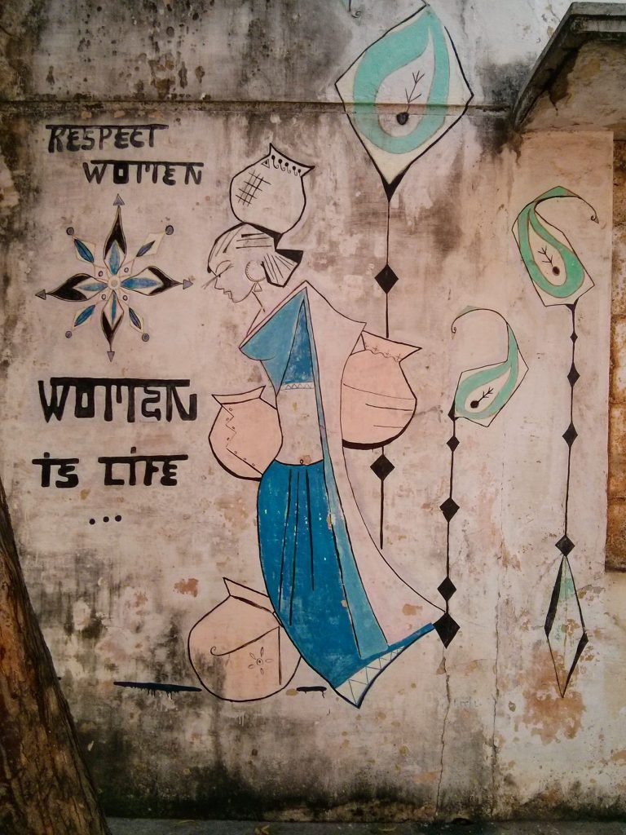
Mural in India. Photo courtesy of Barrett.
The experience in India, as well as his work as a medical scribe in the U.S., have shaped his understanding of homophobia and anti-queer views as largely based on negative views of femininity. In his position as a scribe, he notes, “I observed derogatory comments and misgendering of transgender patients, revealing the lack of LGBT-specific training within healthcare.”
Next, Barrett wants to ground himself in feminist and queer theory in another cross-cultural context to better prepare himself to serve the health needs of LGBT people. The Fulbright U.S. Student Award would allow him to earn a master’s degree in gender studies at Tampere University in Finland before enrolling in an M.D./Ph.D. program.
Jodi Kelber-Kaye, associate director of the Honors College, has enjoyed exciting and fascinating conversations with Barrett, a member of the Honors College, as a mentor. “Robert is willing to ask the ‘what if’ questions that become real possibilities for social change work,” shares Kelber-Kaye. “It is a creative process. He throws out ideas, listens to my thoughts about those ideas, and refines them. He is not afraid to take intellectual risks.”
Kelber-Kaye also reflects, “Mentoring is a combination of practical and personal. This is an academic pursuit for Robert that is also founded in his own identity.” She shares, “He has often remarked that living my life as openly lesbian has helped him see what it looks like to have a rich life that is open and honest.”

The Fulbright U.S. Student Program, funded by the U.S. Department of State, is 60 years old this year. In that time, the distinguished program has selected nearly 400,000 college seniors and recent graduates to represent the United States in study, research, and teaching abroad, including over 50 recipients from UMBC in just the past decade. This year UMBC has produced thirty applicants and twenty-two semifinalists—a record number for the university.
These semifinalists have been selected for their vision to create solutions and serve as leaders around the world. They and the mentors who have supported their journeys—faculty, staff, peers, and family—await with anticipation the final decisions that will launch the next class of Fulbright visionaries.

